Persona Card flow

User flow
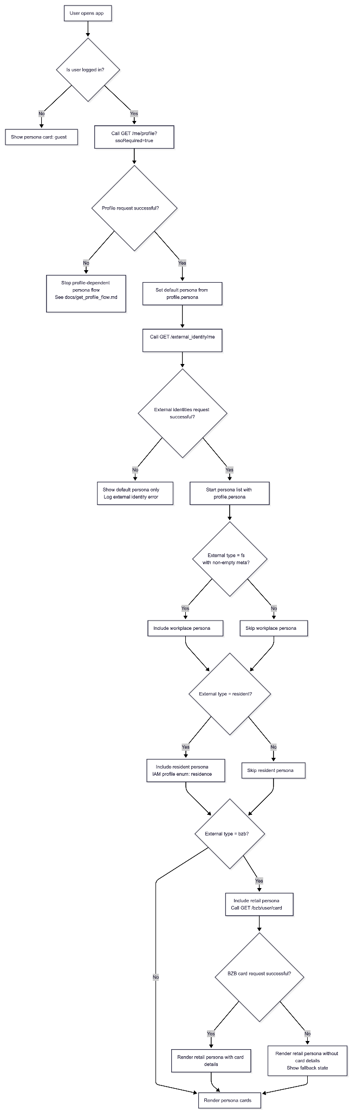

Preview Screen
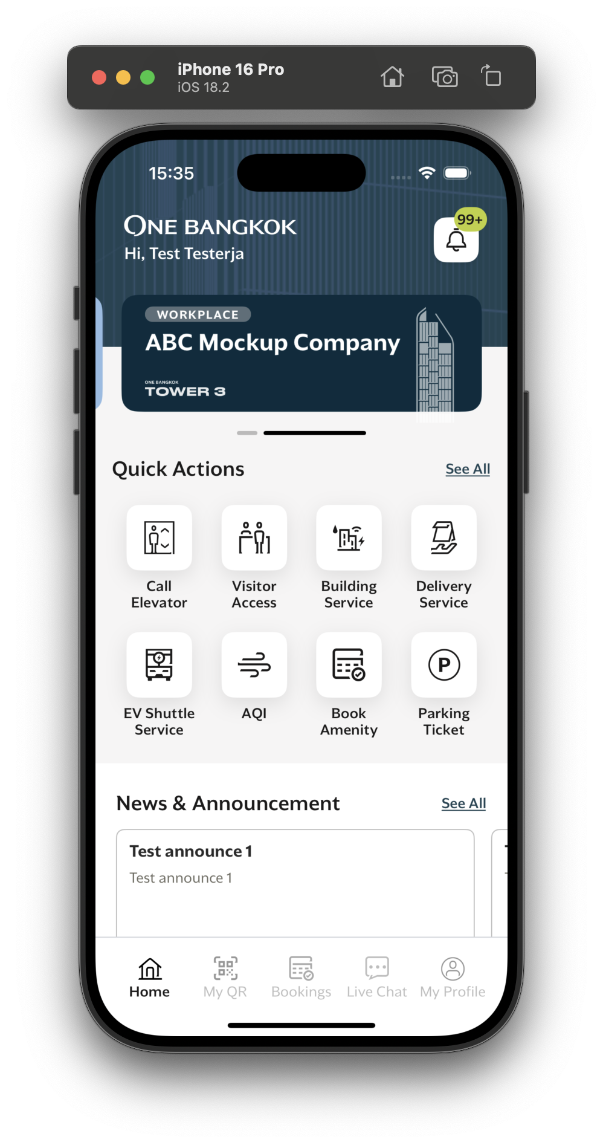
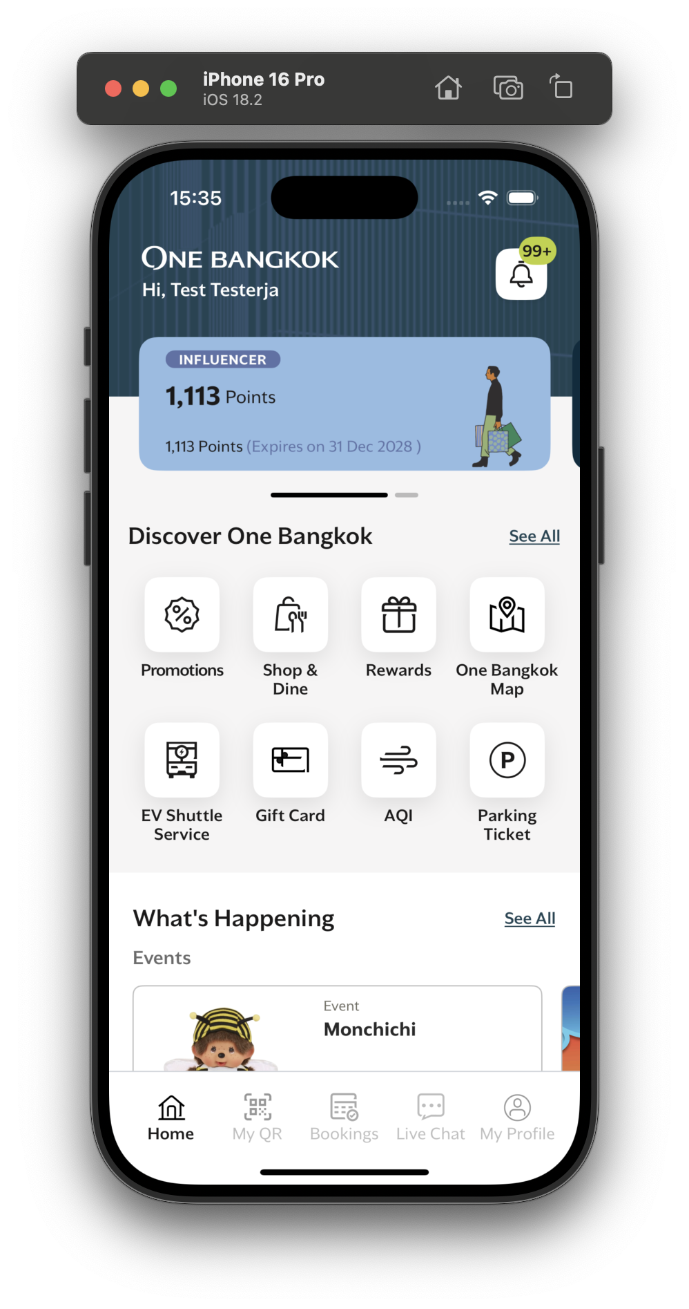

Sequence diagram
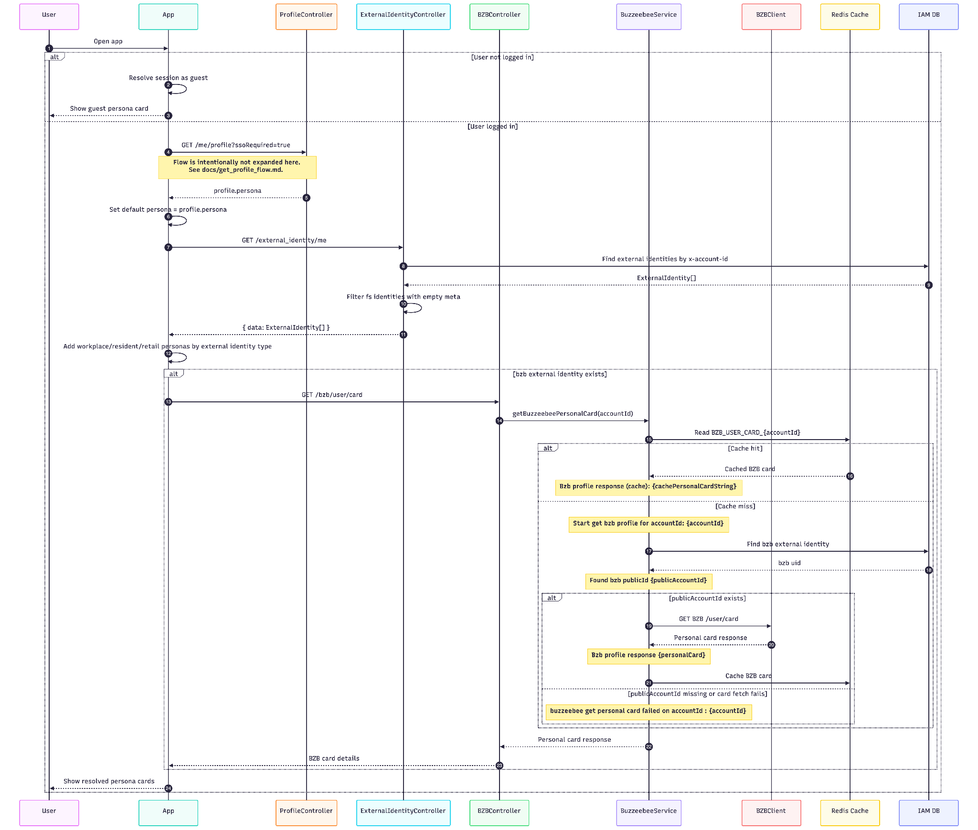

Api description

GET /me/profile
- Purpose: Retrieves the authenticated user's profile. The app uses profile.persona as the default persona.

Request Header
Name | Location | Type | Required | Description
x-access-token | Header | string | Yes | User access token
x-account-id | Header | string | Yes | Account ID used to resolve the profile directly
app-version | Header | string | Optional | Used by profile flow to determine SSO enrichment

Example request
GET /me/profile HTTP/1.1
x-access-token: <access_token>
x-account-id: 123e4567-e89b-12d3-a456-426614174000
app-version: 1.0.1

Example response
{
"data": {
"profile": {
"first_name": "Jane",
"middle_name": null,
"last_name": "Doe",
"dob": "1990-06-12",
"title": "ms",
"gender": "female",
"created_at": "2026-04-15T09:20:30.000Z",
"deleted_at": null,
"sso_profile": {
"firstName": "Jane",
"middleName": null,
"lastName": "Doe",
"birthDate": "1990-06-12T00:00:00.000Z",
"profilePhoto": "https://cdn.example.com/avatar/jane-doe.jpg",
"status": "active",
"addresses": [
{
"id": "address-001",
"type": "home",
"address": "123 Rama IV Road",
"zipCode": "10330",
"province": "Bangkok",
"district": "Pathum Wan",
"subDistrict": "Lumphini",
"country": "TH"
}
],
"emails": [
{
"value": "jane.doe@example.com",
"isDefault": true
}
],
"phoneNumbers": [
{
"value": "+66812345678",
"isDefault": true
}
],
"external": [
{
"value": "BKL_1766404284424",
"provider": "bzb",
"meta": {}
}
],
"meta": {},
"publicId": "sso_123",
"createdAt": "2026-04-15T09:20:30.000Z",
"updatedAt": "2026-04-25T14:05:10.000Z",
"gender": "female",
"idCard": "1234567890123",
"passport": null,
"account": {
"registrationType": "thai"
},
"registrationType": "thai"
},
"registration_type": "thai",
"persona": "user",
"profile_type": "regular_user"
}
}
}

GET /external_identity/me
- Purpose: Returns external identities for the current account. The app uses these identities to add workplace, resident, and retail persona cards.

Request Header
Name | Location | Type | Required | Description
x-account-id | Header | string | Yes | Account ID used to fetch external identities

Example request
GET /external_identity/me HTTP/1.1
x-account-id: 123e4567-e89b-12d3-a456-426614174000

Example response
{
"data": [
{
"id": "ext-fs-001",
"uid": "member-001",
"type": "fs",
"identifier": "jane.doe@example.com",
"account_id": "123e4567-e89b-12d3-a456-426614174000",
"meta": {
"company": "One Bangkok"
},
"created_at": "2026-04-15T09:20:40.000Z",
"updated_at": "2026-04-15T09:20:40.000Z"
},
{
"id": "ext-resident-001",
"uid": "resident-001",
"type": "resident",
"identifier": "jane.doe@example.com",
"account_id": "123e4567-e89b-12d3-a456-426614174000",
"meta": {},
"created_at": "2026-04-15T09:21:00.000Z",
"updated_at": "2026-04-15T09:21:00.000Z"
},
{
"id": "ext-bzb-001",
"uid": "BKL_1766404284424",
"type": "bzb",
"identifier": "BKL_1766404284424",
"account_id": "123e4567-e89b-12d3-a456-426614174000",
"meta": {},
"created_at": "2026-04-15T09:22:00.000Z",
"updated_at": "2026-04-15T09:22:00.000Z"
}
]
}

Response data meaning
Field | Meaning
type | External identity type used for persona mapping
type = "fs" | Include workplace persona only when meta is not empty. The controller filters out fs identities with empty meta
type = "resident" | Include resident UI persona. IAM profile enum name is residence
type = "bzb" | Include retail persona and call GET /bzb/user/card
uid | External system user ID. For bzb, this is the Buzzeebee user ID used server-side to fetch card details
meta | External provider metadata

GET /bzb/user/card
- Purpose: Fetches Buzzeebee personal card details for a user with a bzb external identity.

Request Header
Name | Location | Type | Required | Description
x-account-id | Header | string | Yes | Account ID used to locate the user's bzb external identity

Example request
GET /bzb/user/card HTTP/1.1
x-account-id: 123e4567-e89b-12d3-a456-426614174000

Example response
{
"success": true,
"data": {
"UserId": "BKL_1766404284424",
"PointBalance": 1250,
"PointExpiresItem": {
"Point": 250,
"ExpireDate": 1798765200
},
"Tier": {
"Accumulate": 12000,
"CurrentLevel": 1,
"CurrentLevelName": "Insider",
"MaintainAmount": 10000,
"RemainMaintainAmount": 2500,
"NextLevel": 2,
"NextLevelName": "Influencer",
"TargetLevelUp": 20000,
"RemainTargetLevelUp": 8000,
"TierExpireDate": 1798765200,
"PendingApprove": false
}
}
}

Response data meaning
Field | Meaning
success | Buzzeebee response success flag
data.UserId | Buzzeebee user ID
data.PointBalance | Current available point balance
data.PointExpiresItem | Next expiring point amount and expiration timestamp
data.Tier | Retail membership tier, progress, and expiration details

Cache keys
Key | TTL | Source | Purpose
CACHE_PROFILE_{accountId} | 7200 seconds | ProfileService via CACHE_PROFILE_KEY | Cached IAM profile payload read by GET /me/profile.
EXTERNAL_IDENTITY_CACHE_KEY_account_id_{accountId} | 3600 seconds | ExternalIdentityService.GetExternalIdentity | Cached external identities for the account, used by GET /external_identity/me.
EXTERNAL_IDENTITY_CACHE_KEY_identifier_{identifier} | 3600 seconds | ExternalIdentityService.GetExternalIdentity | Cached external identities by identifier.
EXTERNAL_IDENTITY_CACHE_KEY_uid_{uid} | 3600 seconds | ExternalIdentityService.GetExternalIdentity | Cached external identities by external UID.
EXTERNAL_IDENTITY_CACHE_KEY_KEY_{accountId} | 3600 seconds | ExternalIdentityService | Registry of external identity cache keys for account-level invalidation.
BZB_USER_CARD_{accountId} | BZB_USER_CARD_CACHE_TIME_IN_SECONDS default 300 seconds | BuzzeebeeService | Cached BZB personal card response for the account.
BZB_MERCHANT_TOKEN | BZB_MERCHANT_TOKEN_TTL default 82800 seconds | BZBAuthClient | Cached BZB merchant JWT used for BZB access/auth calls.
BZB_SERVER_TOKEN_{publicAccountId} | BZB_SERVER_TOKEN_TTL default 82800 seconds | BZBAuthClient | Cached BZB server token for the BZB public account ID.
BZB_SERVER_EWALLET_TOKEN_{publicAccountId} | BZB_SERVER_TOKEN_TTL default 82800 seconds | BZBAuthClient | Cached BZB e-wallet token for the BZB public account ID.

